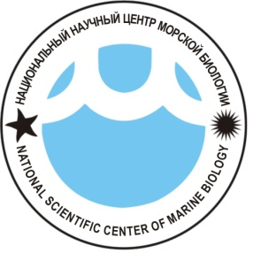
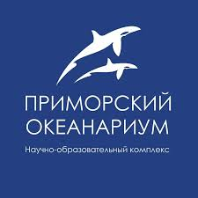

МЕЖДУНАРОДНАЯ КОНФЕРЕНЦИЯ
Морская биология в 21 веке:
достижения и перспективы развития
(к 100-летию со дня рождения академика Алексея Викторовича Жирмунского)
Владивосток, 6 – 8 октября 2021 г.

INTERNATIONAL CONFERENCE
Marine Biology in the 21st Century: Achievements and
Development Prospects
(on the 100th Anniversary of Birth of the Academician Alexei V. Zhirmunsky)
Vladivostok, Russia, October 6 – 8, 2021

REGISTRATION FORM
Please, fill in and return by e-mail to:
Ms. Svetlana Geronina – s_geronina@mail.ru
Registration deadline: June 15, 2021

Submission of Abstracts deadline: June 15, 2021
Abstracts must be submitted to:
Dr. Vadim Serkov – nscmb-conference@mail.ru

Personal Information
Title | Prof. Dr. Mr. Mrs. Ms. Other:
Given Name(s)
Family Name
Affiliation (Institution)
Address
City, State, Zip Code
Country
Phone No. |  | Fax No.
E-mail(s)
Accompanying Person | Mr. Mrs. Ms. Family name: Given Name:
Accompanying Person | Mr. Mrs. Ms. Family name: Given Name:

Presentation
Presentation Title
Type of Presentation | Oral | Poster

Visa support
The conference is expected to be attended – live or online - by leading Russian marine biologists and international scientists; if Covid-19 restrictions are lifted, the organizing committee will assist foreign participants in obtaining documents for entry into the Russian Federation. The session dedicated to the operation of public aquariums will be conducted at the Primorsky Aquarium.
It is planned that one or two special sessions will be run in English, with foreign scientists taking part in them online or in person (the latter will depend on the pandemic situation). If you wish to participate in the conference, please email your completed Registration Form and abstract to the conference organizing committee at nscmb-conference@mail.ru no later than June 15, 2021.
Notification of acceptance or rejection of the abstract will be sent directly to all submitters by email within 7 days of the receipt date (if you fail to receive our notification, please send us your completed Registration Form and abstract again).
General information: Dr. Konstantin Lutaenko, Coordinator – lutaenko@mail.ru

